**GOVERNMENT COLLEGE OF TECHNOLOGY COIMBATORE-641013**

**DEPARTMENT OF ECE**

**SMART WATER FOUNTAIN**

**TEAM MEMBERS**

1. SATHIYA PRAKASH B L -71772114138

2. KRISHNA PRAVEEN S -71772114302

3. MONISHA V - 71772114304

4. SUDHARANI K – 71772114L02

**SMART WATER FOUNTAIN**

**PHASE 2:** Put Your Design into Innovation to solve the Problem.

**LITERATURE REVIEW:**

This section presents the review of related literatures which includes work done on the topic by past researchers. This section will be divided into two segments as follows:

1. Water fountain incorporated with fountain auto refill.
2. Automatic plant watering system has become much common with advancement in technologies. There are several types of plant watering system, depending on the level of automation needed.

**1. Fountain Auto Refill System**:

Automatic refill system provides a simple method to refill a fountain or an aquarium automatically when the water level is below a desired threshold. The reduction in water level might be caused by evaporation or water splash. The system consists of an electronic water pump, a float-switch and a microcontroller. When the water gets too low, the float switch sends a pulse to the microcontroller, and the microcontroller activates the pump. To operate a pump using an Arduino microcontroller, a relay is needed to switch on and off a separate power supply. Aquarium auto refill with Arduino is a simple example of how to use a float switch, small liquid pump and a relay to refill an aquarium once the water level gets too low. But this same technique can be used for pet dishes, water fountains, or any other number of similar applications.

**2. Arduino Based Automated Plant Watering System with Message Alert:**

The block diagram gives the short illustration of what the framework will do in this specific system. **Arduino microcontroller** is used to control the entire procedure of this Plant Watering System. The use of soil sensor circuit is straight forwardly associated with a computerized soil sensor stick with digital pins connected to Arduino. An idea for GSM module in this project is to notify the user by sending SMS.

**BLOCK DIAGRAM**

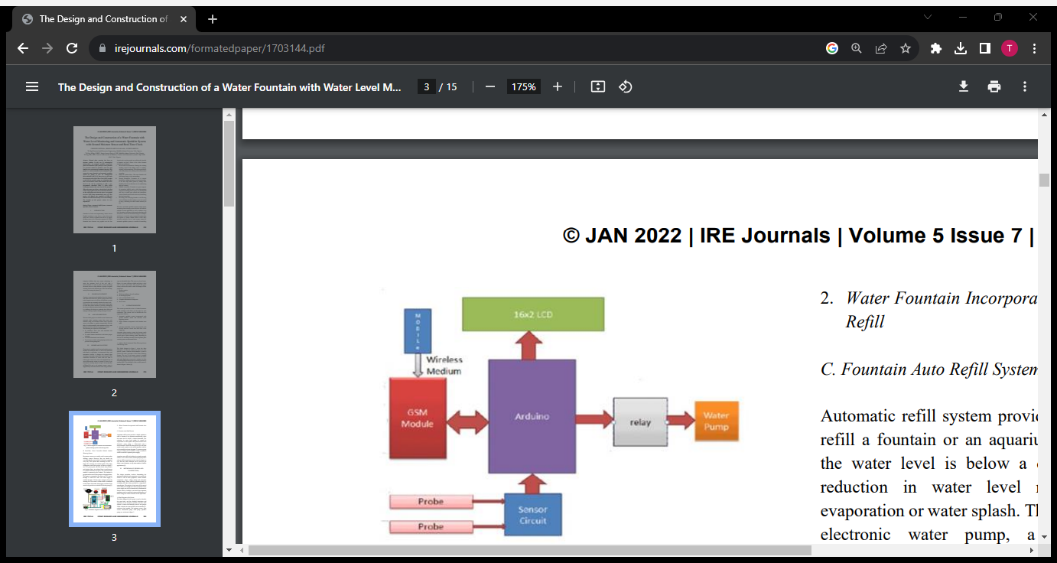

**METHODOLOGY (DESIGN AND CONSTRUCTION)**:

The design procedure involves determining the appropriate materials and components to be used in the circuit as well as their properties; which includes components values, voltage ratings and maximum current ratings. These could be actualized easily by consulting the data sheet provided by component’s manufacturer. The analysis of each unit will be carried out in detail, for example, the value of capacitor in the power supply can only be determined by mathematical analysis where a formula is used and some important parameters such as total load current and frequency of mains voltage are used to calculate for the capacitance.

**Block Diagram of the System** :

The block diagram in this system is used to describe the most basic and less detailed description and operation of the automatic sprinkler and auto refill system. It shows the hardware used in the project which includes the Microcontroller(Arduino uno, ATmega 328P, ESP32),real-time clock module, temperature sensor, flow sensor, pressure sensor, waterlevel sensor, submersible pump, refill pump, valve control, relay, power management.,etc

**BLOCK DIAGRAM OF THE SYSTEM**

**1.ATmega328P Microcontroller IC:**

ATmega328P is a low-power 8-bit microcontroller based on the enhanced RISC architecture. By executing powerful instructions in a single clock cycle, the ATmega328P achieves throughputs approaching 1MIPS per MHz allowing the system designed to optimize power consumption against processing speed. The device is manufactured using Atmel high density non-volatile memory technology. The ATmega328P AVR is supported with a full suite of program and system development tools including: C compilers, macro assemblers, program debugger/simulators, in circuit emulators, and evaluation kits .

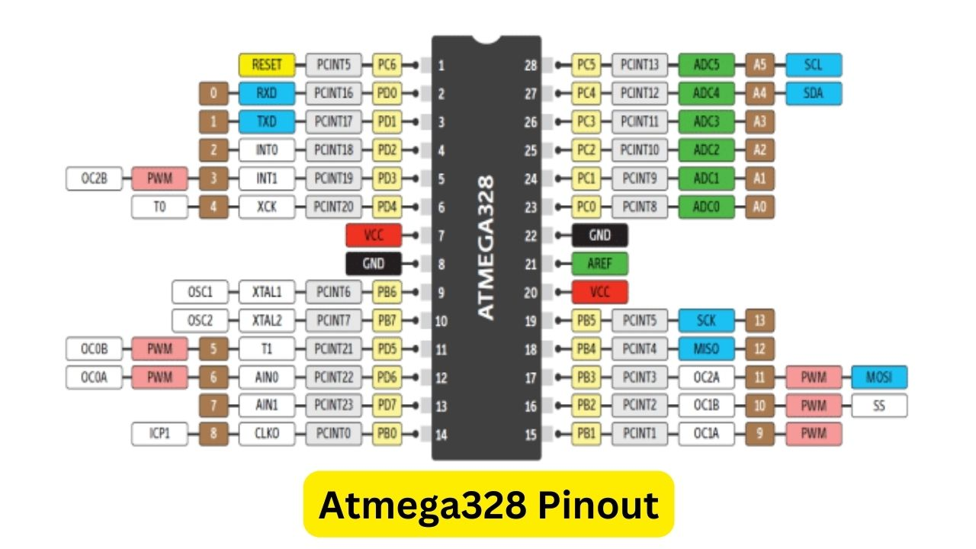

**2.Arduino Uno:**

The Arduino Uno is a popular open-source microcontroller board designed for easy prototyping and DIY electronics projects. It features an ATmega328P microcontroller, digital and analog input/output pins, a USB interface for programming and power, and a simple integrated development environment (IDE) for coding. The board allows users, even those with minimal electronics experience, to quickly create and experiment with interactive projects, making it a staple in the maker and hobbyist communities. Its versatility, affordability, and large community support make the Arduino Uno an excellent choice for learners and enthusiasts exploring the world of embedded systems and programming.

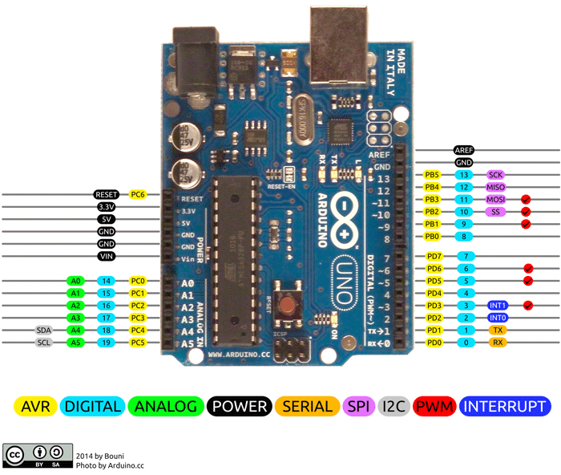

**3.ESP 32 Microcontroller:**

The ESP32 is a powerful and versatile microcontroller and system-on-a-chip (SoC) developed by Espressif Systems. It integrates a dual-core processor, Wi-Fi and Bluetooth connectivity, numerous digital and analog inputs/outputs, and various built-in peripherals. Designed for IoT (Internet of Things) applications, the ESP32 provides a cost-effective solution for wireless communication and control. Its flexibility and capabilities make it popular among developers for a wide range of projects, from simple sensor nodes to complex smart devices. The ESP32's open-source nature and active community support contribute to its widespread adoption in the maker and IoT communities.

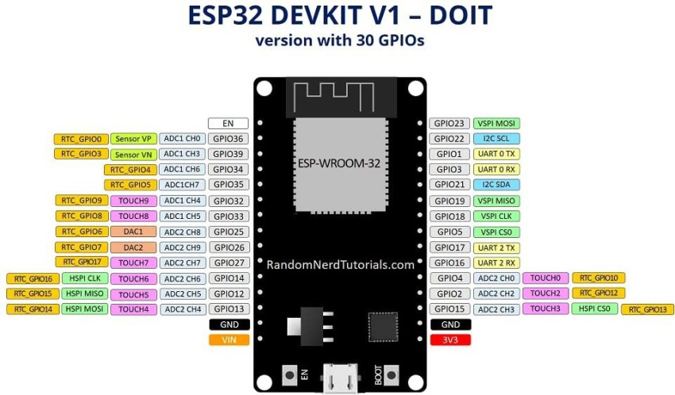

**4. Realtime Clock (DS3231)**:

The DS3231 is a low-cost, extremely accurate I2C real-time clock (RTC) with an integrated temperature compensated crystal oscillator and crystal. The device incorporates complementary metal oxide semiconductor (CMOS) battery to maintains accurate timekeeping when main power to the device is interrupted. The integration of the crystal resonator enhances the long-term accuracy of the device. A precision temperature-compensated reference voltage and comparator circuit monitors the status of VCC to detect power failures, to automatically switch to the backup supply when necessary and to provide a reset output signal. Additionally, the reset pin is monitored as a pushbutton input for generating a reset externally. The pictorial view of the RTC (DS3231) module.

**REAL-TIME CLOCK (DS3231)**

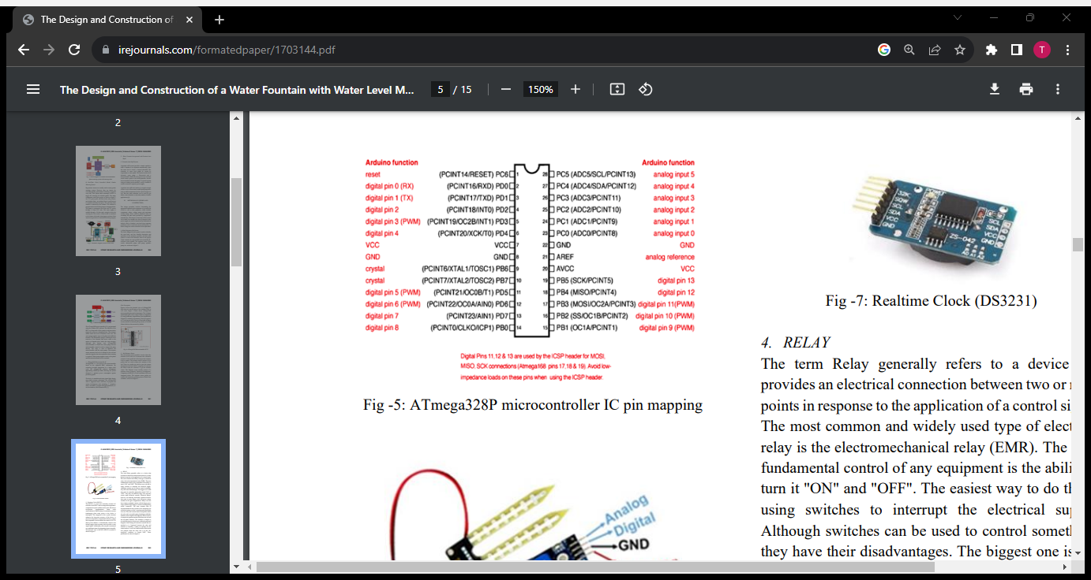

**5. RELAY:**

The term Relay generally refers to a device that provides an electrical connection between two or more points in response to the application of a control signal. The most common and widely used type of electrical relay is the electromechanical relay (EMR). The most fundamental control of any equipment is the ability to turn it "ON" and "OFF". The easiest way to do this is using switches to interrupt the electrical supply. Although switches can be used to control something, they have their disadvantages. The biggest one is that they must be manually (physically) turned "ON" or "OFF". Also, they are relatively large, slow and only switch small electrical currents. Electrical Relays, however, are basically electrically operated switches that come in many shapes, sizes and power ratings suitable for all types of applications. Relays can also have single or multiple contacts with the larger power relays used for high voltage or current switching being called "contactors". The most common form of electromechanical relay consists of an energizing coil called the "primary circuit" wound around a permeable iron core. This iron core has both a fixed portion called the yoke, and a moveable spring-loaded part called the armature, that completes the magnetic field circuit by closing the air gap between the fixed electrical coil and the moveable armature. The armature is hinged or pivoted allowing it to freely move within the generated magnetic field closing the electrical contacts that are attached to it. Connected between the yoke and armature is normally a spring (or springs) for the return stroke to "reset" the contacts back to their initial rest position when the relay coil is in the "deenergized" condition, i.e, turned "OFF".

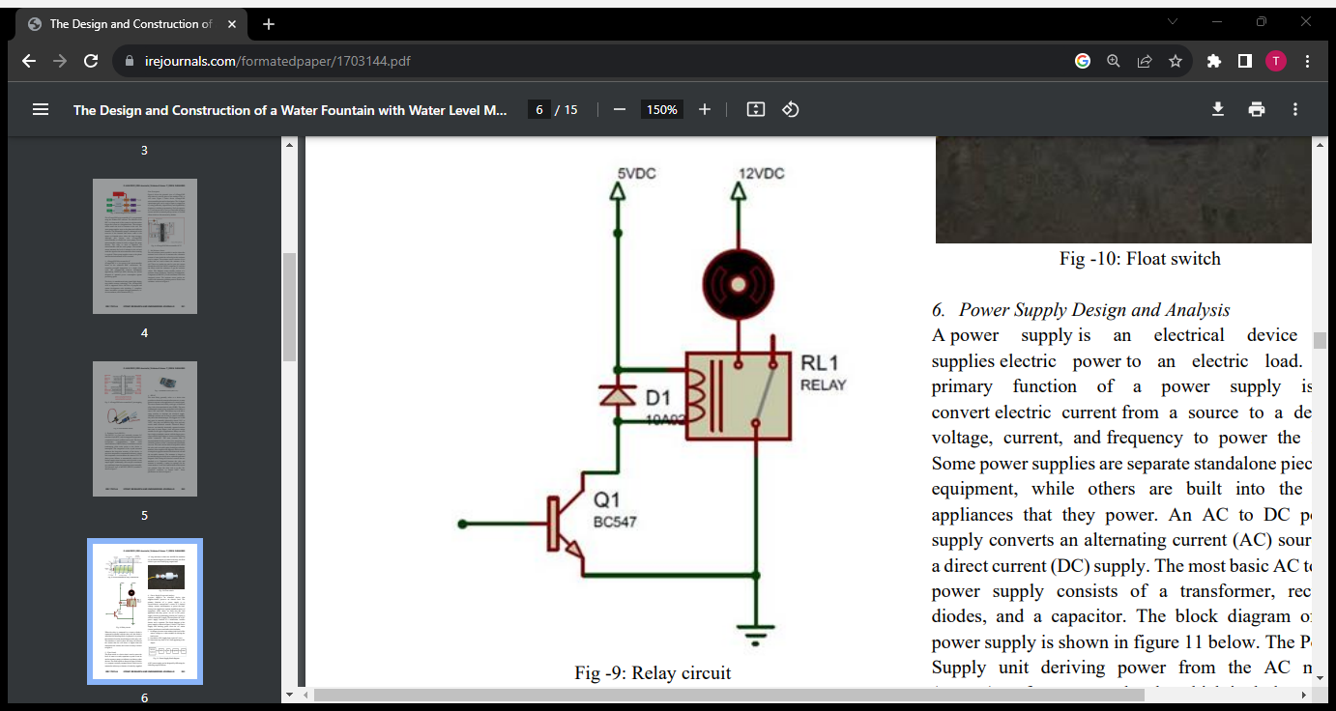

**6. Power Supply Design and Analysis:**

A power supply is an electrical device that supplies electric power to an electric load. The primary function of a power supply is to convert electric current from a source to a desired voltage, current, and frequency to power the load. Some power supplies are separate standalone pieces of equipment, while others are built into the load appliances that they power. An AC to DC power supply converts an alternating current (AC) source to a direct current (DC) supply. The most basic AC to DC power supply consists of a transformer, rectifier diodes, and a capacitor. The Power Supply unit deriving power from the AC mains (source) performs several tasks which includes;

1. It changes (in most cases reduces) the level of the source voltage to a value suitable for driving the load circuit.
2. It produces a DC supply from a pure AC wave.
3. It prevents any form of AC from appearing at the output.

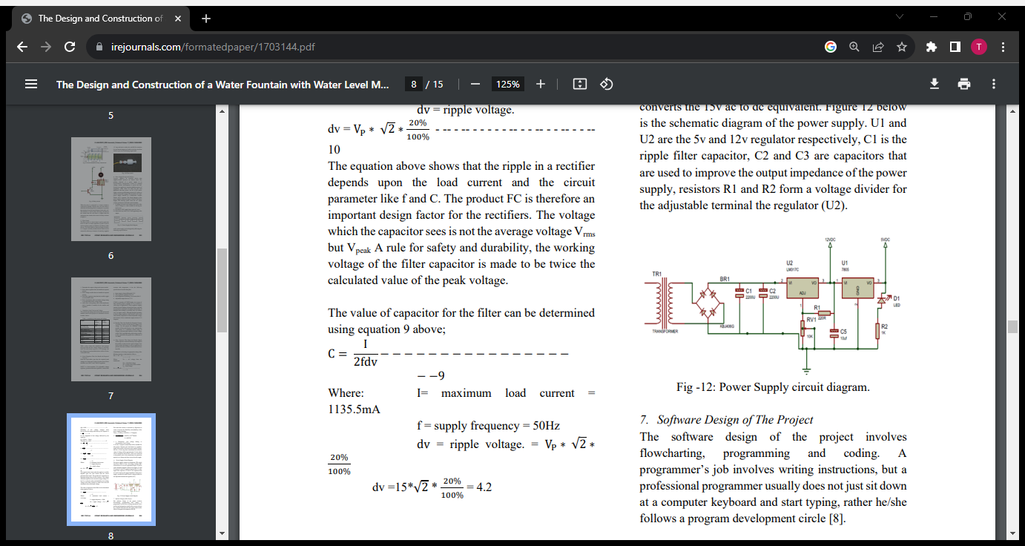

**7. Flow sensor:**

A flow sensor is a device used to measure the rate of flow of a liquid or gas through a system. It plays a crucial role in various applications, including industrial processes, environmental monitoring, and healthcare. Flow sensors are used in a wide range of industries, from monitoring water flow in household plumbing to controlling the flow of chemicals in industrial processes. They are critical in ensuring efficient and safe operation of various systems by providing real-time flow rate data.

**8. Pressure sensors:**

Pressure sensors are devices that measure the pressure of gases or liquids in various applications. They are widely used in engineering, manufacturing, automotive, aerospace, and many other fields. Pressure sensors have a wide range of applications, such as monitoring tire pressure in automobiles, measuring blood pressure in medical devices, ensuring proper fuel injection in engines, controlling industrial processes.

**9. Water level sensor:**

A water level sensor is a device designed to detect and measure the level of water in a container or a natural water source. These sensors are commonly used in various applications, including industrial processes, agriculture, environmental monitoring, and home automation. Water level sensors are essential in controlling water pumps, preventing overflow or dry running, monitoring water resources, and ensuring proper water management. The choice of sensor type depends on the specific application and environmental conditions in which it will be used.

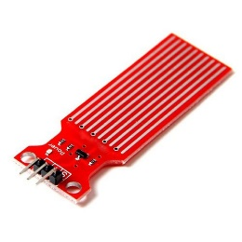

**10. Temperature sensor :**

A temperature sensor is a device that measures the temperature of its surroundings and converts the temperature into an electrical signal or digital data. These sensors are commonly used in various applications, from weather monitoring to industrial processes and consumer electronics. Temperature sensors find applications in various industries, including HVAC systems, automotive, food processing, medical devices, and more. They are essential for maintaining control and monitoring in processes where temperature is a critical factor.

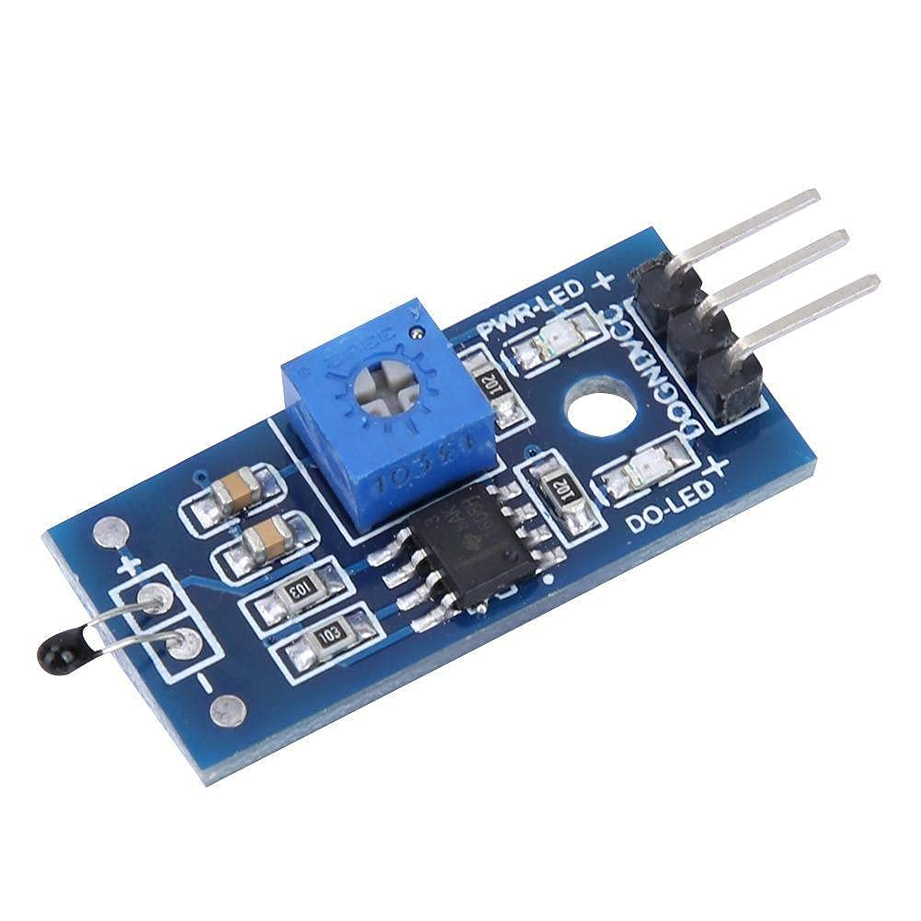

**11.Valve Control:**

Valve control refers to the management and regulation of valves within a system to control the flow of fluids, such as liquids or gases. Valves are mechanical devices that can open, close, or partially obstruct passages to control the flow of a fluid. The control of valves is essential in various industries, including manufacturing, oil and gas, water treatment, and chemical processing.

**12. Submersible Pump:**

A submersible pump is designed to be submerged in the fluid it is pumping, often water. These pumps are typically hermetically sealed to prevent water from entering the motor and electrical components. Submersible pumps are commonly used in wells, boreholes, sewage systems, and other applications where the pump needs to be underwater.

**13. Refill Pump:**

A centrifugal pump is a type of dynamic pump that uses a rotating impeller to increase the pressure of a fluid. It's one of the most common types of pumps and is often used for various applications, including water supply, irrigation, and industrial processes. If you are talking about a pump used for refilling purposes, a centrifugal pump could be suitable for tasks like refilling water tanks or reservoirs.

**STEPS ARE REQUIRED TO SMART WATER FOUNTAIN:**

**Design Thinking Steps**

**Determine Desired Effects:**

* Consider the desired impact on public spaces.
* Assess the size of the water fountain and surroundings.

**Define Pool Characteristics:**

* Determine the size, shape, and depth of the fountain pool.
* Consider location, materials, and available water supply.

**Select Pump and Piping:**

* Choose a pump based on the fountain's size and effect desired.
* Consider the use of centrifugal turbines or submersible pumps.

**Choose Filters:**

* Select filters for water clarity, including sand filters and pump filter screens.
* Consider chemical addition for water treatment.

**Define Plumbing and Equipment Location:**

* Plan plumbing for pump and filter systems.
* Locate sensors, lights, and junction boxes within the pool.
* Consider anti-vortex plates and other safety features.

**Determine Lighting Requirements:**

* Define lighting for overall illumination and visual effects.
* Place underwater lights strategically for accentuating elements.

**Define Controls:**

* Specify controls, including timers, motor starters, and valves.
* Consider both electro-mechanical and microprocessor controls.

**Consolidate Equipment:**

* For simple fountains, use small panels.
* Larger water effects may require a dedicated building or vault.

**Fit for the Future**

**Consider Wellbeing and Sustainability:**

* Ensure the project aligns with urban development goals.
* Enhance the liveability of the area through water features.

**Future-Proof Design:**

* Consider the scalability and adaptability of the IoT system.
* Utilize sustainable practices for water usage.

**Community Engagement:**

* Promote community engagement through the public platform.
* Use water fountains to beautify spaces, enhance cooling, and boost the local economy.

**Quality Built Environment:**

* Align with global trends focusing on the quality of built environments.
* Ensure the project is fit for the future in terms of technology and sustainability.

**Conclusion:**

The conclusion for this project, specifically regarding fault detection in the public water fountains. With the implementation of IoT sensors, the project has successfully enhanced the monitoring of public water fountains, allowing for real-time data collection and analysis.The project has contributed to the efficient usage of water resources by enabling real-time control of water flow. This can help prevent water wastage and ensure responsible water usage.The IoT sensors integrated into the water fountains have proven effective in promptly detecting malfunctions. This not only reduces downtime but also helps prevent water contamination or other safety issues. The real-time information about water fountain status is accessible to residents through a public platform, promoting awareness and engagement. Users can be informed of operational fountains, helping them make informed choices.The successful integration of IoT technology and Python scripting has enabled the seamless flow of data from the sensors to the water fountain status platform, ensuring that residents have access to up-to-date information. In conclusion, this project has effectively addressed its objectives, enhancing public water fountains through IoT sensor deployment, fault detection, and real-time status communication. It not only contributes to water conservation but also improves the overall experience for residents and visitors.